Channel Charting-Based Localization Algorithm Competition

Background

|  |  |  |  |
| --- | --- | --- | --- |
| Prepared by | Sweden Research Center, Algorithm Lab | Date | 2024-10 |



华为技术有限公司

Huawei Technologies Co., Ltd.

版权所有 侵权必究

All rights reserved

修订记录Revision record

|  |  |  |
| --- | --- | --- |
| 日期  Date | 修订版本Revision version | 修改描述  change Description |
| 2024-05-31 | V1.0 | First version |
| 2024-06-06 | V1.1 | Modifying the background information |
| 2024-06-12 | V1.2 | Modifying description to the data file |
| 2024-10-28 | V1.3 | Modifting the task description |
|  |  |  |
|  |  |  |
|  |  |  |
|  |  |  |
|  |  |  |
|  |  |  |
|  |  |  |
|  |  |  |
|  |  |  |

**Terminology:**

|  |  |
| --- | --- |
| ECID | Enhanced Cell ID |
| SS-RSRP | Secondary Synchronization Reference Signal Received Power |
| SS-RSRQ | Secondary Synchronization Reference Signal Received Quality |
| RTT | Round Trip Time |
| SRS | Sounding Reference Signal |
| PRS | Positioning Reference Signal |
| TRP | Transmission and Reception Point |
| CC | Channel Charting |
| NR | New Radio |
| PDP | Power delay profile |
| CSI | Channel state information |
|  |  |

# Task Background

## 5.5G Overview

5.5G is a technology planned for the period preceding 6G maturity, addressing the ongoing expansion of 5G's business scale and the accelerating pace of digitalization and intelligent transformation. As an evolution of 5G, 5.5G is expected to feature Hybrid Communication and Sensing, aiming to achieve multi-purpose networking that supports both communication and sensing functions. This technology is envisioned for applications across various scenarios, including smart transportation and vehicle-road coordination. A key requirement for sensing in these applications is the precise localization of targets based on wireless signals, which remains a critical and challenging research area.



Figure 1: The vision of 5.5G.

## **Current Status of Wireless Localization Algorithms**

The current 5G systems supports various localization functions, where base stations mainly use uplink pilot signal for localization. Typical wireless localization principles are as follows:

* **Time Difference of Arrival (TDoA) Method**: The transmitting node (i.e., the UE) sends signals to different receiving points. Multiple receiving nodes calculate the distance differences between the UE and various nodes based on the time differences in signal arrival. By using the hyperbola principle, the distance difference between the user and two base stations can be determined, resulting in a set of hyperbolas that help calculate the user's location.
* **Angle of Arrival (AoA) Method**: The direction of the incoming signal can be estimated using an antenna array at the receiver. For a base station acting as the receiver in a direct path environment, the direction of the incoming signal corresponds to the user's direction relative to the base station. If AoA estimates from multiple receivers are used, the intersection of the direction lines provides the estimated location of the signal source.
* **Multi-Cell Round Trip Time (RTT) Method**: By measuring the transmission and reception times of signals between base stations and the UE, the UE's position can be inferred. The basic principle involves defining a circle with the base station as the center and the distance from the UE to the base station as the radius. The intersection of three such circles determines the UE's location.

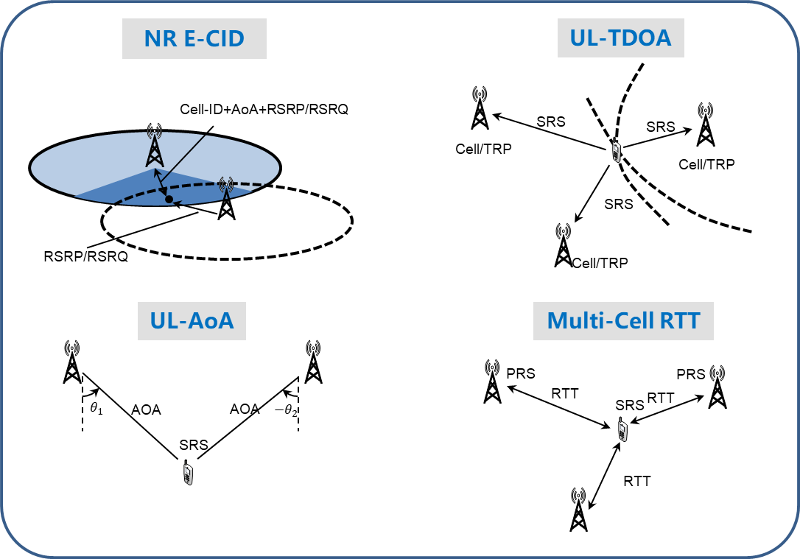

Figure 2: Typical wireless localization methods

In addition, fingerprint-based positioning is also a common wireless positioning method. This approach involves collecting and modeling radio characteristic data from known locations, and then using the model to match fingerprints from unknown measurements to determine the location. Various signal attributes within a cell, such as signal strength, Angle of Arrival (AoA), and multipath delay, can be used as fingerprints.

## **Challenges of Wireless Positioning Algorithms**

The wireless positioning methods mentioned above can achieve meter-level accuracy with simple measurement and calculation schemes in open areas, near Line of Sight (LOS) conditions, high signal-to-noise ratio (SNR), and wide bandwidth scenarios. However, in real-world conditions, several challenging situations can arise, including but not limited to:

* **Single-Station Positioning**: In some cases where user UE communicates with only a single base station, traditional multi-station positioning algorithms fail. Relying solely on single-station information can degrade positioning accuracy.
* **Low Signal-to-Noise Ratio (SNR) Scenarios**: It becomes difficult to distinguish between multipath components and noise, leading to inaccuracies in measurements.
* **Non-Line of Sight (NLOS) Scenarios**: The power delay profile (PDP) becomes complex, making it challenging to extract accurate first paths, which complicates the measurement of delays and angles.
* **Acquiring Real-World Position Markers**: Fingerprint-based positioning performs better in complex scenarios, but building a fingerprint database requires a significant number of real-world position markers, demanding substantial human and material resources.

## **Channel Charting-Based Positioning**

As shown in Figure 3, in a wireless transmission environment, typical channel characteristics such as angle and delay are determined by the user’s location and the scattering environment. This implies that an environmental map combined with the user’s location can be used to characterize the wireless channel features of a wireless communication system. However, in practice, constructing high-precision environmental maps and obtaining high-precision user locations are quite challenging.

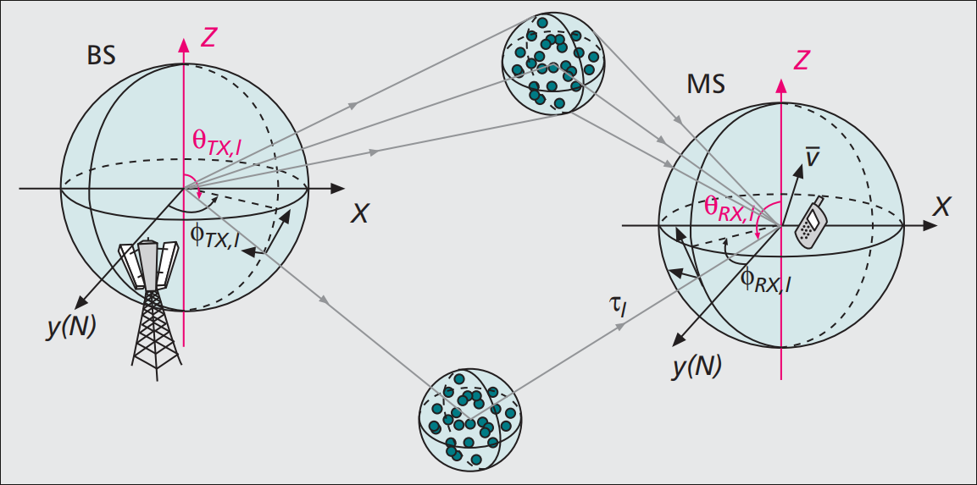

Figure 3: Wireless transmission environment

On the other hand, wireless communication systems measure users' channel state information (CSI) to achieve efficient data transmission, and the systems themselves can collect a large amount of CSI data. The CSI contains implicit information about the scattering environment, and channel charting (CC) is a technique that uses CSI to characterize the wireless transmission environment. CC aims to map high-dimensional CSI to a low-dimensional virtual coordinate in a latent space that correspond to channel characteristics, such that users with similar low-dimensional virtual coordinates also have similar channel features. Generally, in real environments, users who are physically close to each other often have strongly correlated steady-state channel features; Similarly, if two users' steady-state features are highly correlated, there is also a high probability that their physical locations are close. As illustrated in the CC example shown in Figure 4, users in similar physical environments (same color) remain close in low-dimensional virtual coordinates.

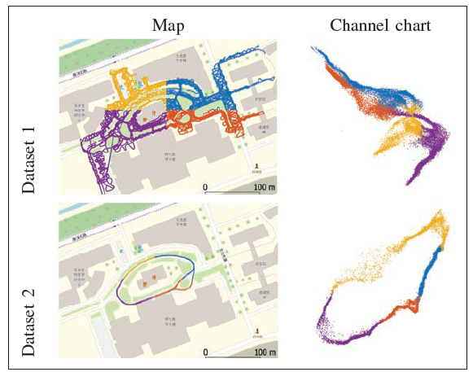

Figure 4: Example of Channel Charting [1]

Generally, the construction of CC relies on the correlation of channel characteristics between users and does not include users' absolute position information. Therefore, the mapped low-dimensional virtual coordinates only reflect the relative positions between users and do not represent absolute positions. If some users' absolute position information can be obtained, it may be possible to correct the relative position information provided by the chart to absolute positions. This method is referred to as CC-based positioning technology. Compared to traditional fingerprint-based positioning, this approach can significantly reduce the number of absolute position labels required, thanks to the relative position information provided by the chart. Additionally, compared to traditional multi-station measurement positioning, CC can potentially achieve single-station positioning without relying on information from multiple stations.

Here is a brief introduction to some typical methods for constructing CC. The typical process is illustrated in Figure 5.

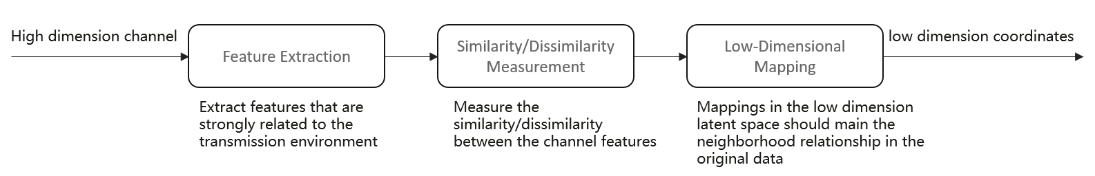

Figure 5: Channel Charting Construction Process

* The feature extraction module aims to extract channel characteristics, which are strongly related to the transmission environment.
* Similarity/dissimilarity measures assess the distance between channel features, with common methods including Euclidean distance, cosine similarity, and others.
* Low-dimensional mapping involves projecting high-dimensional CSI features into a lower-dimensional space, while maintaining the relative distance relationships of the high-dimensional CSI features.

Some typical low-dimensional mapping methods used in Channel Charting construction [3][4] include:

* Multidimensional Scaling (MDS): The optimization obejective of the MDS method is given as follows:

,

Here represents the total number of samples, denotes the distance between high-dimensional CSI samples under a certain distance metric, represents the low-dimensional coordinates to be optimized. The objective function aims to optimize the low-dimensional coordinates such that the Euclidean distance between the low-dimensional coordinates closely approximates the distance under the high-dimensional CSI.

* Siamese: Siamese is a neural network-based method, and its network structure is depicted as follows:

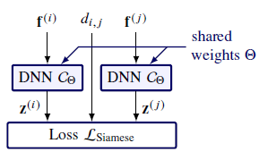

Its loss function is

,

which has the same form as the objective of MDS optimization.

* Triplet: Triplet is also a neural network-based method, and its network structure is as follows.

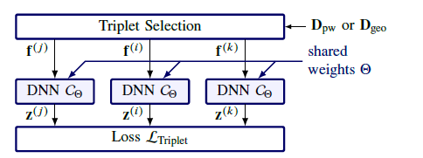

Its loss function is:

,

where represents a triplet constructed with sample as the anchor point based on high-dimensional CSI distance metrics, where (This does not appear in the formulation). The objective of the loss function is to ensure that, in the low-dimensional coordinates, sample points that are close in high-dimensional CSI distances are as close as possible, and those that are far apart are as distant as possible.

## **Challenges Faced by Channel Charting-Based Positioning**

Inevitably, CC-based positioning faces several challenges due to practical factors:

* **Number of UEs with Known Absolute Positions**: Obtaining a large number of UEs with known absolute positions is often impractical under real-world conditions, as it may require significant resources. Therefore, the goal is to achieve the highest possible positioning accuracy with as few UEs with known positions as possible.
* **Uneven Spatial Distribution of UEs with Known Positions**: In practice, it is difficult to cover every area of the target region with UEs having known positions. As a result, the spatial distribution of UEs with known true positions will inevitably be uneven, which may increase the difficulty of relative position correction on the chart.
* **Low Signal-to-Noise Ratio (SNR) Scenarios**: The construction of channel charts relies heavily on accurate CSI data. In low SNR scenarios, the accuracy of the user’s CSI information is compromised, which presents a significant challenge to the accuracy of channel charting.

# References

[1] Ferrand P, Guillaud M, Studer C, et al. Wireless channel charting: Theory, practice, and applications[J]. IEEE Communications Magazine, 2023, 61(6): 124-130.

[2] Studer C, Medjkouh S, Gonultaş E, et al. Channel charting: Locating users within the radio environment using channel state information[J]. IEEE Access, 2018, 6: 47682-47698.

[3] Stephan P, Euchner F, Ten Brink S. Angle-delay profile-based and timestamp-aided dissimilarity metrics for channel charting[J]. IEEE Transactions on Communications, 2024.

[4] Ferrand P, Decurninge A, Ordoñez L G, et al. Triplet-based wireless channel charting[C]//GLOBECOM 2020-2020 IEEE Global Communications Conference. IEEE, 2020: 1-6.